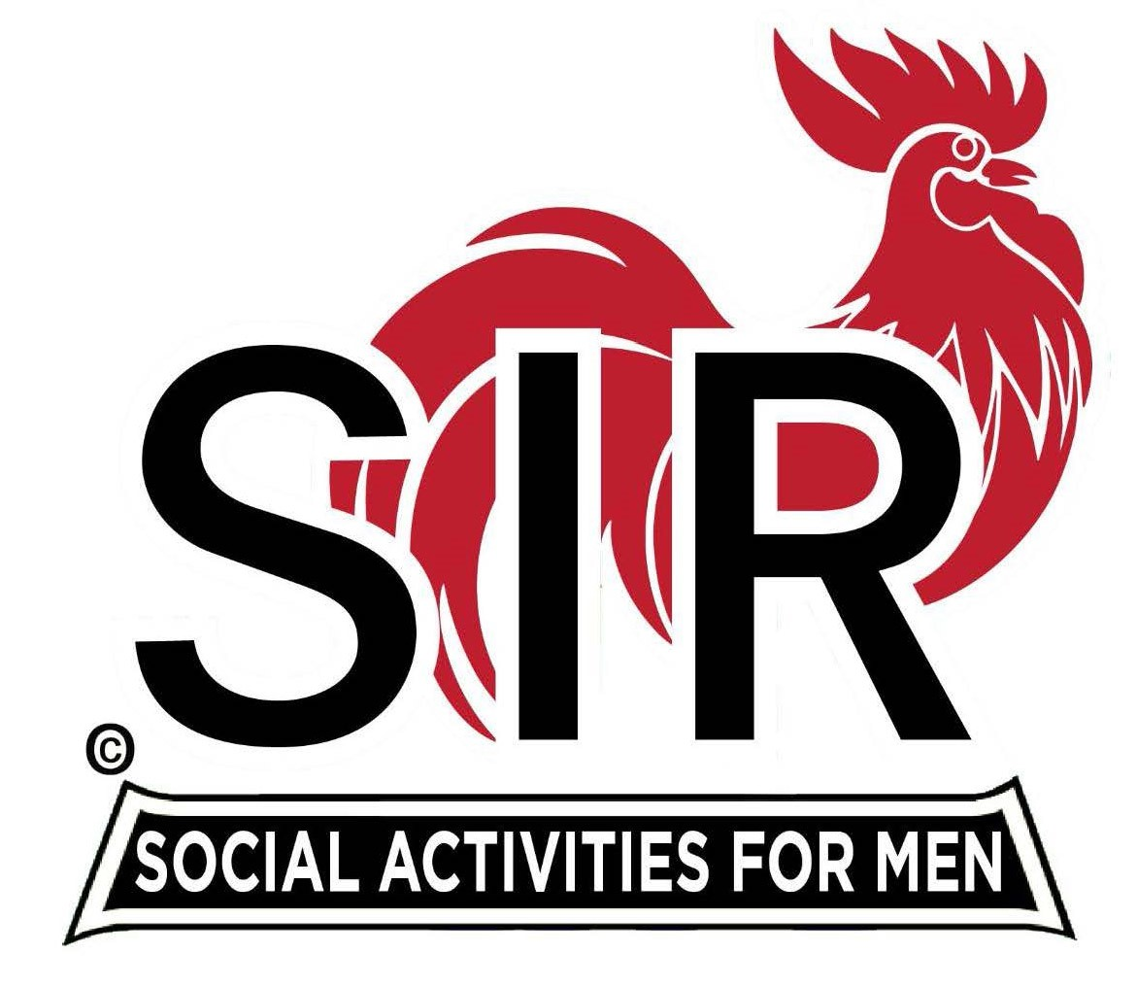
Las Trampas Branch 116
BEC Meeting Agenda
April 15, 2024, 9:15 AM at Boundary Oak
The Mission of SIR is to enhance the lives of our members through fun activities, events and luncheons while making friends for life.

9:15 am Call to order; Secretary, Paul Ramacciotti – Confirm quorum and
Approval of March 18, 2024 BEC meeting minutes

9:20 am Standing Reports
- Treasurer – Charlie Guthrie

- Luncheon Report – Dennis Snarr
  - April 15 Boundary Estimated Count

- Sunshine/Remembrance – Alan Pope
  - Marty Grummit
  - Sunshine Report

- Membership – Alan Fitzgerald
  - Membership Changes
  - “Inactive”, “Active”, and Terminated status- Alan Pope

- RAMP Department Head Reports:
- Recruitment – Don Schroeder
  - New members: Noel Concepcion, Sponsor: Peter Loew; Kirk Harding, Sponsor: Don Schroeder; Garrett Romain, Sponsor: Steve Beck; Jim Ranger, Sponsor: Tom O’Brien
  - Guests: Doug Roaldson, Sponsor: Roger Craig;
- Activity Coordinator – Mike Ward
- Member Relations - (need volunteer)
- Publicity – Robin Lemmo
  - Status – Diablo Gazete

9:40am Big SIR Report – Alan Pope
- Sunshine Report
- Active/Inactive/Terminated
- Spring Fling

Little SIR Updates – Paul Russell
- Speaker Info – Ron Baskett
- Birthday Boys – April

9:50 am Updates & New Business
- Luncheons – Sam Beret
- Lunch Seating – new member table

10:15 am Adjourn: Lunch Preparations

